Report on Graduates Admission Prediction

About Dataset:
This dataset is about “Prediction of Graduate Admissions” that based on some essential parameters i.e.: GRE Score, TOEFL Score, University Rating, Letter of Recommendation, CGPA, Research etc.
Analysis &Content:
Dataset contains under given important parameters which are considered mainly during application

Parameters description:

- GRE Scores ( out of 340 )
- TOEFL Scores ( out of 120 )
- University Rating ( out of 5 )
- Statement of Purpose -(SOP) Strength ( out of 5 )
- Letter of Recommendation-(LOR) Strength ( out of 5 )
- Undergraduate GPA-CGPA ( out of 10 )
- Research Experience ( either 0 or 1 )
- Chance of Admit ( ranging from 0 to 1 )

Here is the Sample of the “Prediction of Graduate Admissions”
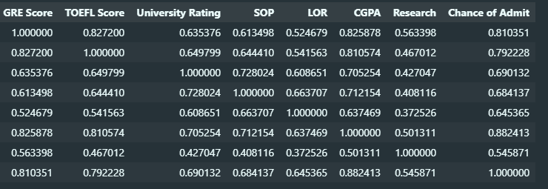

Virtual representation of the data:
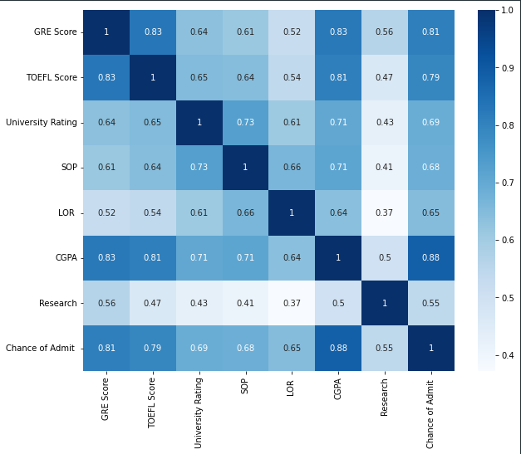
Graphical Representation:
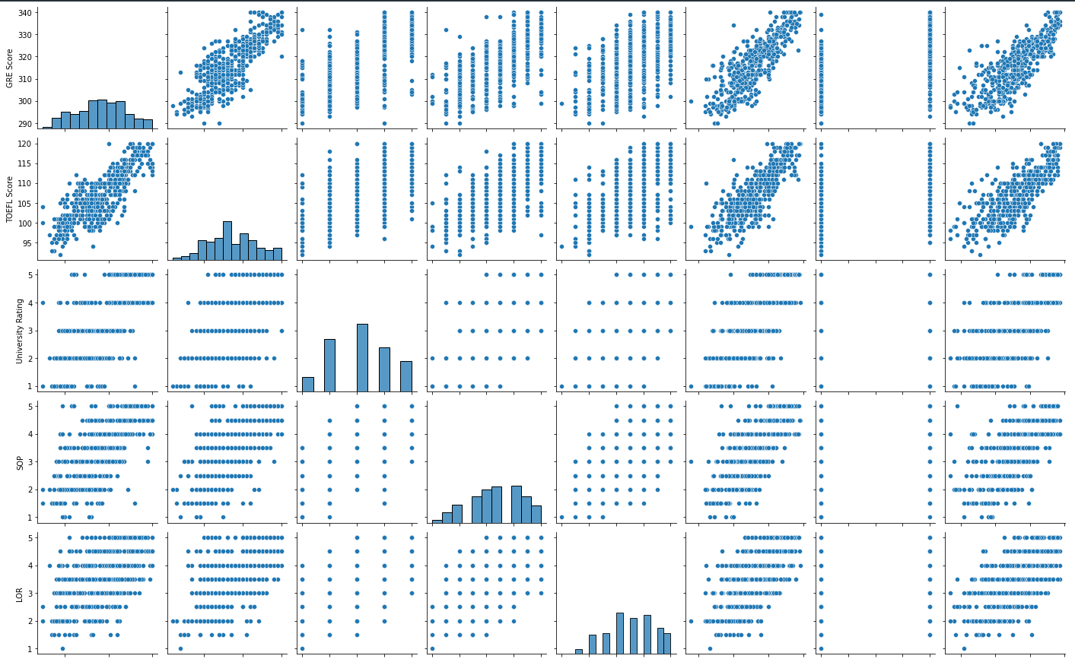

Conclusion:
Results will help students in shortlisting universities with their profiles. It also helps students easy to understand the current score by showing the different representation of data.
Predicted output can provide students a fair idea about their chances for a particular university.

